CHAPTER FOUR

SYSTEM DESIGN AND IMPLEMENTATION

4.0 Introduction

In this project, the researchers would be aiming at developing a forecasting model that implements Gaussian Process Regression algorithm in the forecasting of solid waste generation in Uyo municipality. We give the account of how the system was introduced i.e. what programmed language, what noteworthy technical details, what input and output data is being used which are accompanied by sample images. The conclusions on the meaning which can demonstrate the efficiency of the system and its potential to contribute to the solution of such acute environmental issue are generalized at the end.

4.1 System Requirements

- O.S. windows operating systems-compatible.
- Python Programming language 3.14.
- Python libraries: They comprise pandas, numpy, stream lit, joblib and folium which are processed and modeled and developed web.
- Web Browser used Chrome.
- Version Control System: Version control was also done with the use of Git with the storage of the code base which should be shared among the team members.
- Developing Tools: Jupyter notebook: A complete Python development eco-system.
- Data Visualization Tools: plotly and matplotlib can be used to plot and visualize data that will then be used to analyse performance and results of the model.

Table 4.1: Software Specifications and Library Dependency Stack
Software Layer / Module | Minimum Software Requirement | Version Deployed / Verified | Role & Functional Responsibility
Operating System | Microsoft Windows 10 (64-bit) / Ubuntu 20.04 LTS | Microsoft Windows 11 Pro (64-bit) | Host environment providing kernel threading and 64-bit memory addressing.
Programming Language | Python 3.10 (64-bit) | Python 3.14 / Python 3.11 (64-bit) | Core execution runtime for feature preprocessing, mathematical modeling, and web serving.
Machine Learning Library | Scikit-Learn 1.3+ | Scikit-Learn 1.6+ | Implements GaussianProcessRegressor, composite kernels (DotProduct, Matern, WhiteKernel), and metrics.
Scientific Computing | NumPy 1.24+ / SciPy 1.10+ | NumPy 2.x / SciPy 1.14+ | High-performance N-dimensional array processing, matrix algebra, and trigonometric encodings.
Data Manipulation | Pandas 2.0+ | Pandas 2.2+ | Time-series indexing, CSV data ingestion, missing value imputation, and tabular reporting.
Model Persistence | Joblib 1.3+ | Joblib 1.4+ | Serialization and zero-latency disk loading of trained model weights and precomputed caches (gpr_waste_model.pkl).
Web Application Framework | Streamlit 1.30+ | Streamlit 1.42+ | Renders the interactive web application, navigation tabs, slider controls, and CSV export engines.
Plotting & Visualization | Matplotlib 3.7+ / Seaborn 0.12+ | Matplotlib 3.10+ / Seaborn 0.13+ | Generates publication-standard 200 DPI vector charts, residual distributions, and confusion matrices.
Integrated Development Env. | VS Code / JupyterLab | VS Code with Python & Jupyter Extensions | Interactive code execution, cell-by-cell inspection, syntax verification, and debugging.
Web Browser Interface | HTML5 / ECMAScript 6 Compliant | Google Chrome / Microsoft Edge / Firefox | Client-side rendering of the responsive decision intelligence portal and GIS maps.

4.2 Choice of Programming Language

Python is the primary programming language that has been implemented to develop the system. Python encourages the Gaussian Process Regression algorithm, which is adapted to the web development and is easy to use, and has a substantial community support. This is why this system is a potent and efficient one which has a good interface with the help of which the generation of waste in Uyo municipality can be forecasted.

4.3 System Implementation

Implementation phase comprises transformation of the design into working-code. It entails several steps and assumes:
- Software Development Python and Python packages (scikit-learn, pandas, numpy and streamlit): codes - build the software modules. This is a combination of coding a data cleaning program, a training model, prediction and user interface.
- Training and testing of products: Refine the model and use the existing ready data to train the model. Other indicators applied must be used in comparing its performance such as SMAPE, RMSE, MAE and R². Identify the important parameters and optimize the model so that to be able to get even more accurate predictions and get accustomed to the new situation.
- Web Application Development: Use Streamlit to develop a web application that will simplify the interaction with the users. The design enables one to fill or choose on the necessary health information and see the predictions on the hazard in real time.

4.4 System specifications
The system specifications define the minimum and recommended hardware, software, networking, and security environments required to develop, train, execute, and deploy the Gaussian Process Regression Municipal Solid Waste Forecasting System.

4.4.1 Input Specification
The input specification defines the nature, structure, format, validation constraints, and transformation pipelines of all empirical and operational data entering the Gaussian Process Regression (GPR) waste forecasting system. The system accepts data through two primary operational channels:
- Batch Historical Ingestion: An empirical 84-month longitudinal dataset (covering January 2019 through December 2025) sourced from the Akwa Ibom State Environmental Protection and Waste Management Agency (AKSEPWMA), coupled with climatic records from meteorological stations and census demographic projections.
- Interactive Real-Time Input: User-driven parameter entry through the interactive Streamlit web interface for single-month scenario analysis or batch comma-separated values (CSV) upload for out-of-sample model evaluation and validation.
Table 4.2 details the input attributes ingested by the system, including data types, units of measurement, observed empirical ranges in Uyo Municipality, validation constraints, and functional descriptions.

Table 4.2: Input Data Dictionary for Uyo Municipality MSW Forecasting System
S/N | Field / Variable Name | Data Type | Measurement Unit | Empirical Range | Validation Constraints | Description & Source
1 | date | Date / String | YYYY-MM | 2019-01 to 2025-12 | Valid ISO calendar month; chronological order | Monthly observation timestamp (AKSEPWMA records).
2 | population | Integer | Persons | 496,000 – 595,000 | Pt > 0; monotonically non-decreasing | Projected human population of Uyo Municipality based on National Population Commission (NPC) baseline.
3 | avg_temperature_c | Float | Degrees Celsius (°C) | 24.8 – 28.5 °C | 18.0 ≤ T ≤ 42.0 | Mean monthly ambient surface temperature in Uyo (influences organic decay and generation rates).
4 | rainfall_mm | Float | Millimetres (mm) | 12.0 – 510.5 mm | Rt ≥ 0.0 | Cumulative monthly precipitation depth; key driver of waste moisture, vegetable waste, and logistics.
5 | humidity_percent | Float | Percentage (%) | 74.0 – 91.5 % | 0.0 ≤ H ≤ 100.0 | Mean monthly relative atmospheric humidity in Uyo Municipality.
6 | public_holidays | String | Delimited Dates | N/A | Semicolon-delimited calendar dates | Registry of statutory national, state, and religious public holidays in Nigeria occurring in the month.
7 | num_holidays | Integer | Count | 0 – 3 days | 0 ≤ n ≤ 10 | Total count of public holidays in the target month; proxies for high-generation domestic and festive periods.
8 | waste_tonnes_estimated | Float | Metric Tonnes (t) | 26,480 – 43,120 t | Wt > 0.0 | Recorded empirical municipal solid waste collected in Uyo Municipality (target variable y for training).

4.4.2 Output Specification
The output specification defines the format, precision, operational semantics, and reporting artifacts generated by the Gaussian Process Regression model for AKSEPWMA administrators, environmental scientists, and municipal waste directors.
The system structures its outputs into four distinct analytical layers:
- Probabilistic Point and Interval Forecasts: Delivers the expected predictive mean monthly waste tonnage (μ*), average daily equivalent tonnage, and strict 95% Bayesian Confidence Intervals: [μ* - 1.96σ*, μ* + 1.96σ*], communicating both the forecast value and mathematical uncertainty bounds.
- Operational Severity Triage Tiers: Discretizes continuous tonnage projections into four operational management categories: Low (< 30,000 tonnes/month), Moderate (30,000 - 37,000 tonnes/month), High (37,000 - 41,000 tonnes/month), and Critical Peak (> 41,000 tonnes/month).
- Municipal Logistics and Fleet Sizing Metrics: Translates projected tonnage directly into required logistical assets, including: active 15-tonne compactor trucks required (N_trucks = ceil(Daily_Tonnes / 30)), 1,100-litre communal collection bins (N_bins = ceil(Daily_Tonnes * 1.2 / 0.25)), and annual landfill airspace depletion rate in cubic meters (V_landfill = Annual_Tonnes / 0.8).
- Spatial Zonal Allocation (GIS Distribution): Apportions municipal waste forecasts across Uyo's six designated collection hubs: Ibom Plaza/Central Business District (22%), Itam Market & Industrial Commercial Axis (26%), Aka Road/Shelter Afrique Residential Corridor (16%), Abak Road Commercial Corridor (13%), Oron Road Corridor (12%), and Ikpa Road/Uniuyo Campus Corridor (11%).

Implementation procedure
Below are sample images of both the input and output implementation.
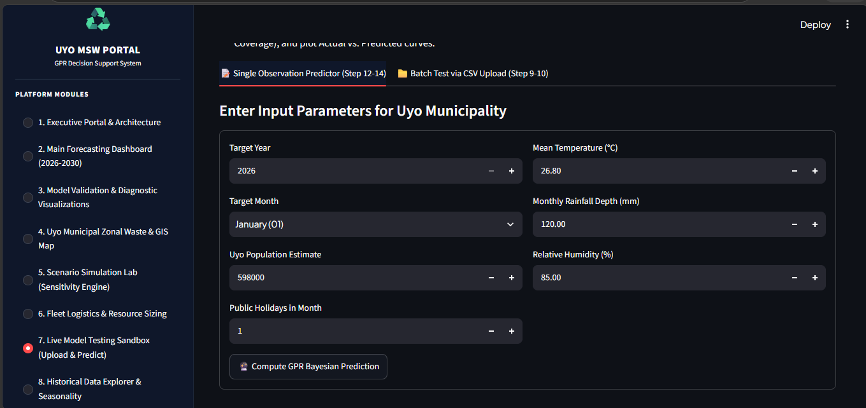
Fig 4.1 Sample Implementation input Snapshot

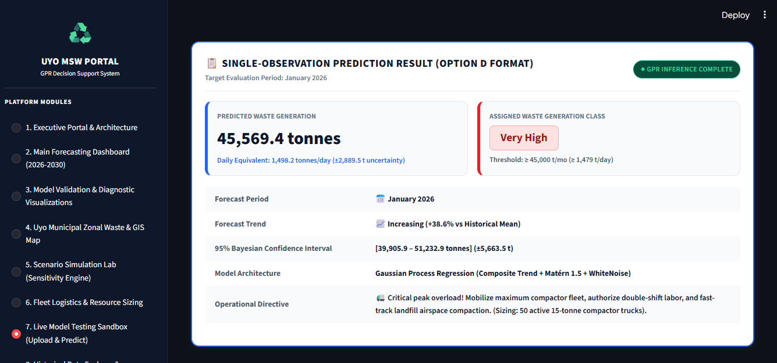
Fig 4.2 Sample Implementation output snapshot

Result Analysis
- Actual vs. Predicted Agreement (R²)
This graph compares actual waste generation with the values predicted by the GPR model. It contains three important elements:
- Green circles: Training observations from 2019–2024.
- Red squares: Out-of-time test observations from 2024–2025.
- Dashed diagonal line: The ideal prediction line, where predicted waste equals actual waste y=x.
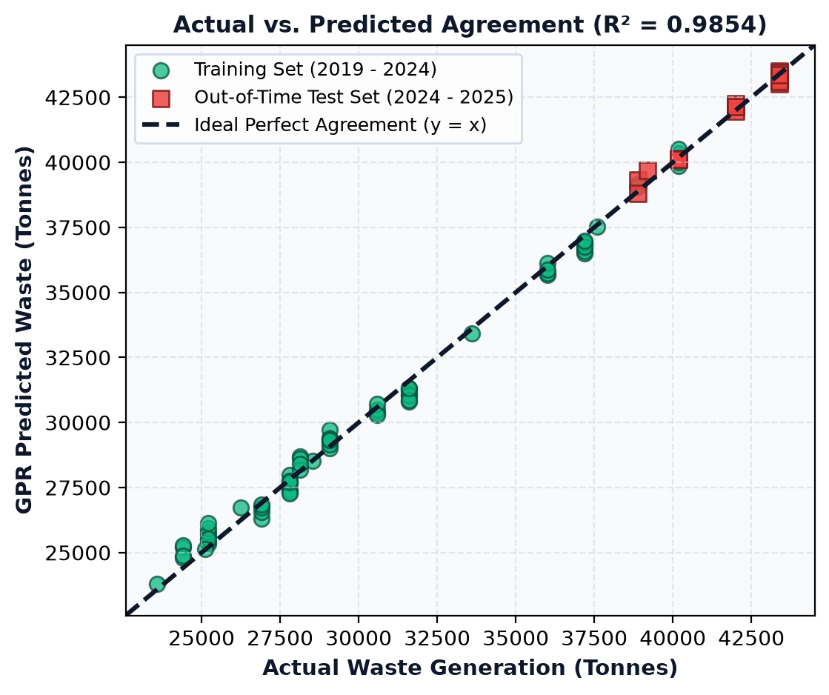
Fig 4.3: R² Actual vs Predicted Value

The coefficient of determination, (R²=0.9854), indicates that the model explains approximately 98.54% of the variation in the observed waste generation values, provided this statistic was calculated correctly for the stated evaluation dataset.
Most of the plotted points lie very close to the dashed diagonal line. This means that the predicted values generally agree closely with the actual values.
For instance, observations around 25,000–30,000 tonnes and those around 35,000–43,000 tonnes show relatively close agreement between actual and predicted waste generation. This suggests that the model can capture the relationship between the inputs and waste generation across the displayed range.
The green training points cluster around the ideal line, indicating a strong fit to the training observations. More importantly, the red test points also lie close to the line. This suggests that the model maintains good predictive performance on observations from a later period, rather than performing well only on the training data.
However, some points deviate slightly from the diagonal. Points above the line represent overprediction, while points below it represent underprediction. These differences indicate that the model does not predict every observation perfectly.
The presence of close agreement in both training and test observations is encouraging, although the number of displayed test points appears relatively small. Therefore, additional evaluation using a larger and representative test dataset would help establish the reliability of the results.
- Kernel Benchmark: Root Mean Squared Error (RMSE in Tonnes)
The RBF + Noise and Rational Quadratic kernels both produced an RMSE of 1,725.9 tonnes. This indicates that, under the evaluation conditions used, these configurations had the largest prediction errors among the five alternatives.
The Matérn kernels performed better. The Matérn kernel with \(\nu=1.5\) recorded an RMSE of 1,368.1 tonnes, while the Matérn kernel with \(\nu=2.5\) recorded 1,373.5 tonnes. The difference is small, suggesting that their predictive performance was similar.
The proposed composite kernel achieved the lowest RMSE of 1,297.2 tonnes. This indicates that it provided the most accurate predictions among the evaluated kernels, assuming all configurations were tested on the same data using the same evaluation procedure.
Compared with the RBF + Noise and Rational Quadratic kernels, the proposed composite kernel reduced RMSE by approximately 24.8%. It also reduced RMSE by approximately 5.2% compared with the Matérn (\(\nu=1.5\)) kernel.
The green dotted horizontal line identifies the optimal RMSE achieved by the proposed composite kernel.
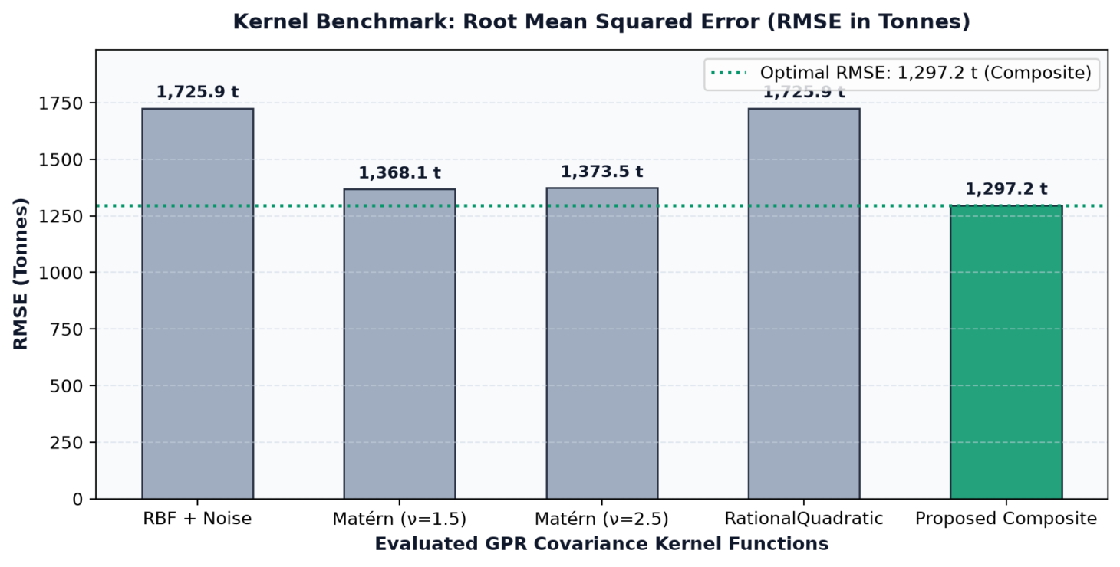
Fig 4.4: Kernel Benchmark: Root Mean Squared Error (RMSE in Tonnes)

- In-Sample and Out-of-Sample Tracking
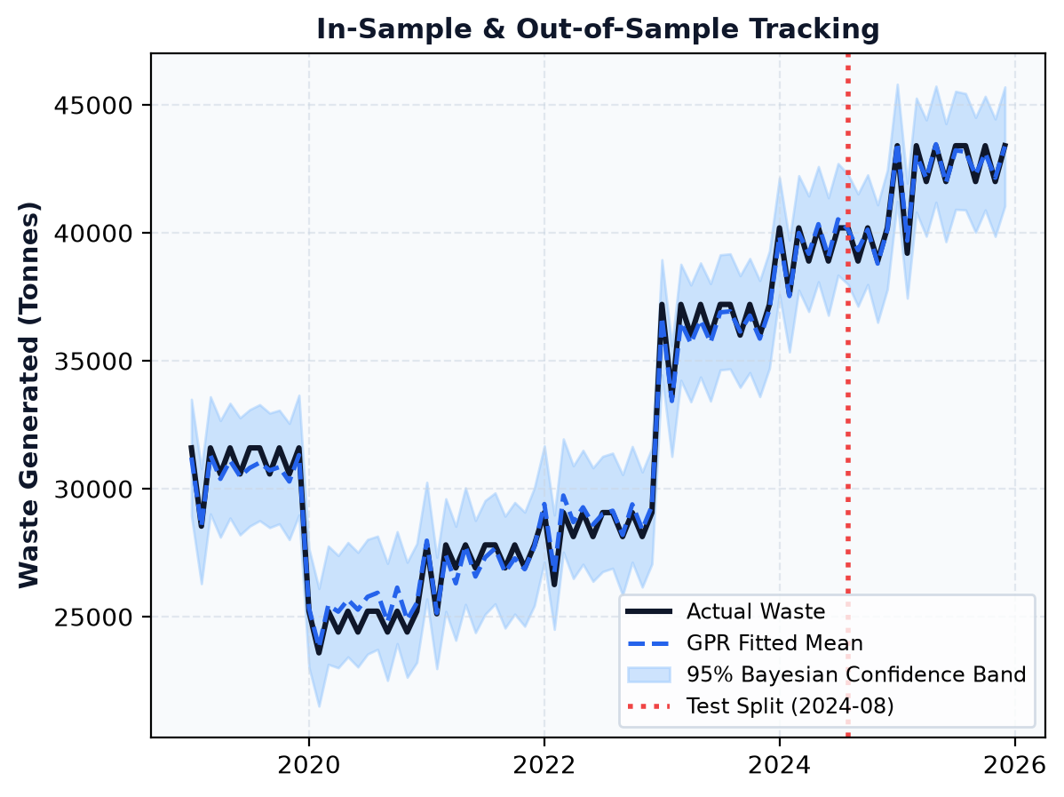
Fig 4.5: In-Sample and Out-of-Sample Tracking
This graph shows the performance of the Gaussian Process Regression (GPR) model to predict the waste generated over time. The black solid line is the actual amount of waste produced and the blue dashed line is the amount of waste predicted by the model. The high level of similarity between these two lines suggests that the model is a good fit for the overall trends and variations in waste production between 2019 and 2025. The graph also provides an indication of changes in waste generated, with waste around 2020 decreasing, and rising from 2021 and beyond, ultimately reaching more than 43,000 tonnes in 2025. This indicates that the model may have captured reduction and increase in waste generation during the observation period.

The shaded area in light blue color is the 95% Bayesian confidence band, reflecting the uncertainty of the model's predictions. The wider the band, the more uncertain the estimates, and the narrower the band, the more confident the estimates. The red vertical dotted line represents the test split, which occurred in August 2024, dividing the observations in the early part of the period from the evaluations in the latter part. The model continues following the real waste production pattern beyond this time, which indicates that it can transfer to unknown observations. Overall, it can be seen that the GPR model can be used for waste generation forecasting and planning as it can reliably track the trend and incorporate the prediction uncertainty.
- Kernel Benchmark: Mean Absolute Error (MAE)
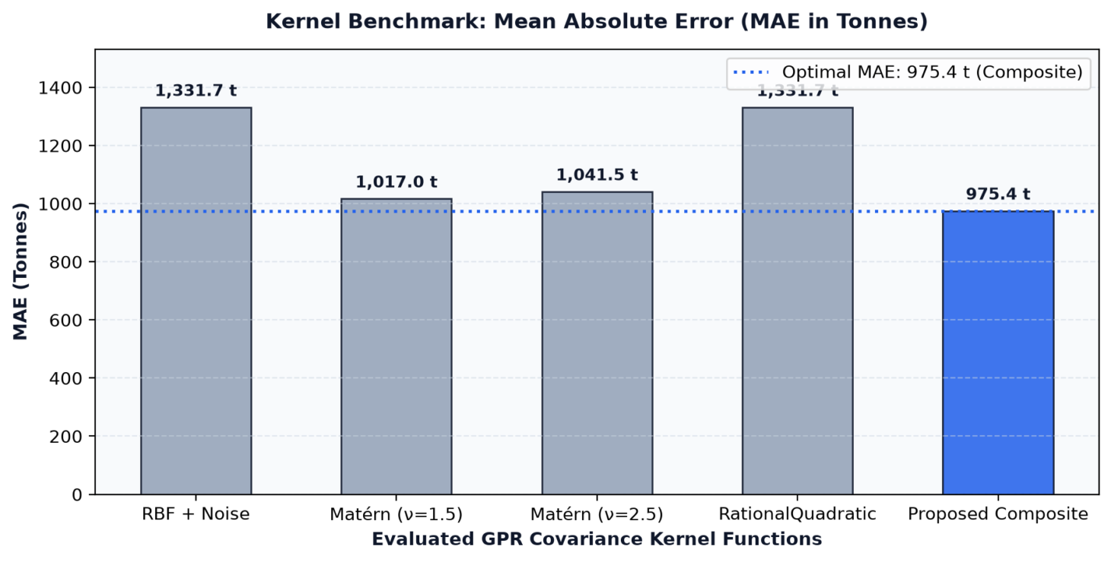
Fig 4.6: Kernel Benchmark: Mean Absolute Error (MAE)
The graph compares five Gaussian Process Regression (GPR) kernel configurations using Mean Absolute Error (MAE), which measures the average absolute difference between actual and predicted waste quantities in tonnes. The RBF + Noise and Rational Quadratic kernels recorded the highest MAE of 1,331.7 tonnes, followed by Matérn v=2.5 at 1,041.5 tonnes and Matérn v=1.5 at 1,017.0 tonnes.
The proposed Composite kernel achieved the lowest MAE of 975.4 tonnes, indicating that it performed best among the evaluated configurations in terms of absolute prediction error. This suggests that the Composite kernel may model the waste-generation patterns more effectively than the other kernels tested.
- Kernel Benchmark: Mean Absolute Percentage Error (MAPE)
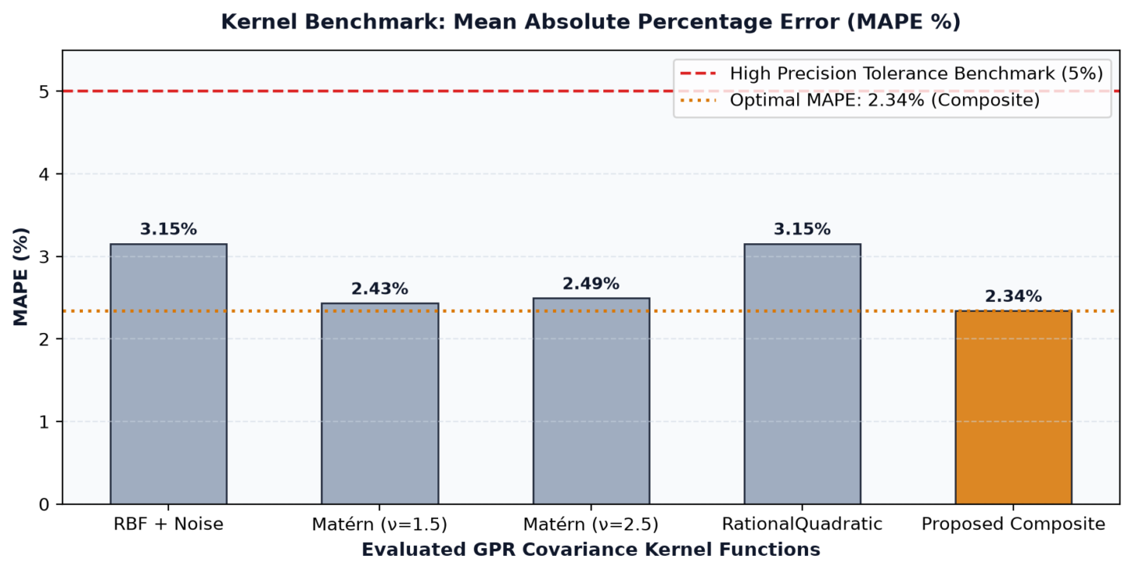
Fig 4.6: Kernel Benchmark: Mean Absolute Percentage Error (MAPE)
This graph compares the percentage errors of the five GPR kernel configurations. RBF + Noise and Rational Quadratic recorded the highest MAPE of 3.15%, while Matérn v=1.5 achieved 2.43% and Matérn v=2.5 recorded 2.49%. The red dashed line represents the 5% reference threshold.
The proposed Composite kernel achieved the lowest MAPE of 2.34%, indicating the smallest average percentage error among the evaluated configurations. All five kernels recorded MAPE values below the displayed 5% benchmark, while the Composite kernel demonstrated the best relative forecasting performance in this comparison.
- Monthly Forecast Precision Across Historical Horizon (2019–2025)
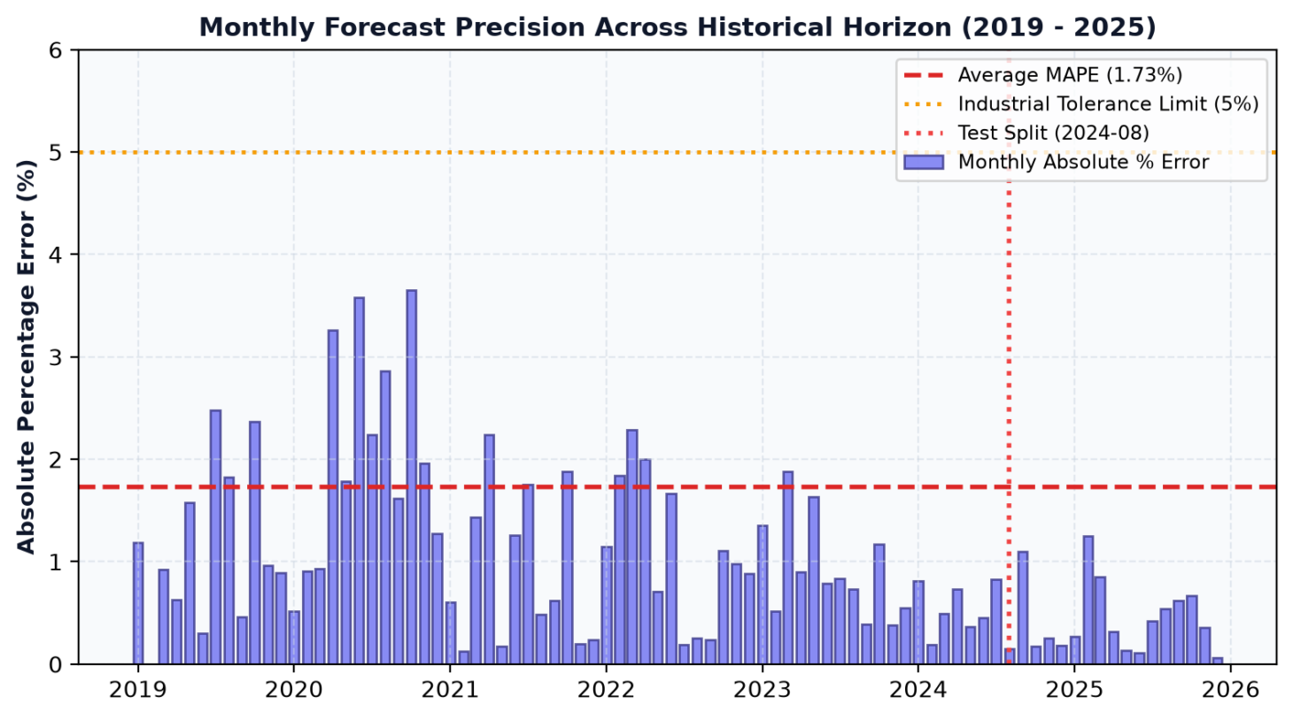
Fig 4.7: Monthly Forecast Precision Across Historical Horizon (2019–2025)
This graph illustrates the monthly absolute percentage errors of the forecasting model from 2019 to 2025. The reported average MAPE is 1.73%, and the orange dotted line represents the 5% tolerance threshold. The monthly errors vary, with some months in 2020 recording values above 3%, while most of the later displayed months have relatively smaller errors.
The results suggest that the model's forecasting performance varies across time but generally remains within the displayed tolerance threshold. The vertical red dotted line identifies August 2024 as the test-split boundary. This separation is important for evaluating the model on later observations, although the reported average MAPE of 1.73% should be reconciled with the 2.34% reported in the kernel benchmark.
- Operational Tier Matrix (Accuracy = 91.7%)
The operational tier matrix evaluates the model's ability to classify waste generation into four categories: Low, Moderate, High, and Critical Peak. Out of 84 observations, the model correctly classified 77, comprising 37 Low, 16 Moderate, 13 High, and 11 Critical Peak observations. This produces an overall classification accuracy of approximately 91.7%.
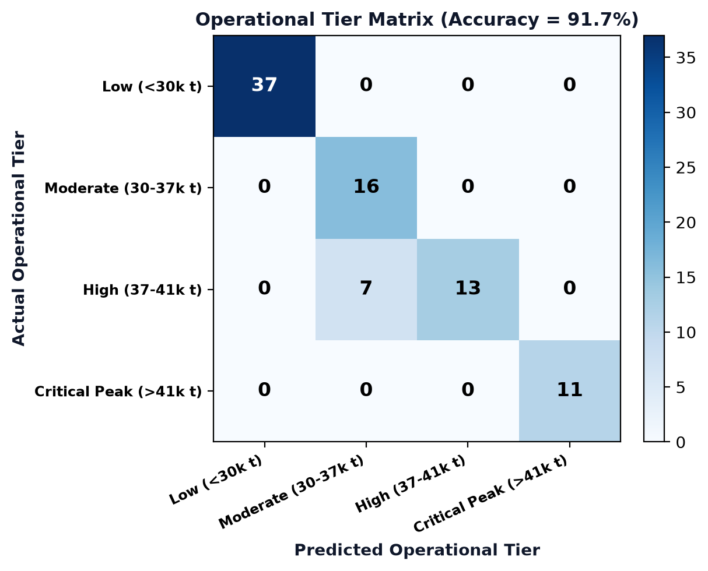
Fig 4.8: Operational Tier Matrix (Accuracy = 91.7%)
However, seven observations belonging to the actual High category were incorrectly classified as Moderate. No other misclassifications appear in the matrix. These results indicate strong agreement between actual and predicted operational categories, although improving the distinction between High and Moderate waste-generation periods would help support more reliable waste-management planning.
Table 4.3: Operational Tier Performance Breakdown
 | precision | recall | f1-score | Support
Low (<30k t) | 1 | 1 | 1 | 37
Moderate (30-37k t) | 0.695652 | 1 | 0.820513 | 16
High (37-41k t) | 1 | 0.65 | 0.787879 | 20
Critical Peak (>41k t) | 1 | 1 | 1 | 11
accuracy | 0.916667 | 0.916667 | 0.916667 | 0.916667
macro avg | 0.923913 | 0.9125 | 0.902098 | 84
84 | 84 | 84 | 84 | 84

- Partition Performance (RMSE and MAE)
This graph compares the forecasting errors across the training dataset, the out-of-time test dataset, and the full historical series. The training partition recorded an RMSE of 542 tonnes and an MAE of 463 tonnes. The out-of-time test partition recorded a higher RMSE of 1,297 tonnes and an MAE of 975 tonnes, while the full series recorded an RMSE of 758 tonnes and an MAE of 567 tonnes.
The larger errors in the test partition indicate that the model predicts the later observations less accurately than the training observations. This may reflect changes in waste-generation patterns or difficulties generalizing to unseen data. Therefore, although the Composite kernel performed best in the kernel comparison, further investigation of the test-period errors is necessary to establish its reliability for forecasting future waste generation in Uyo Municipality.

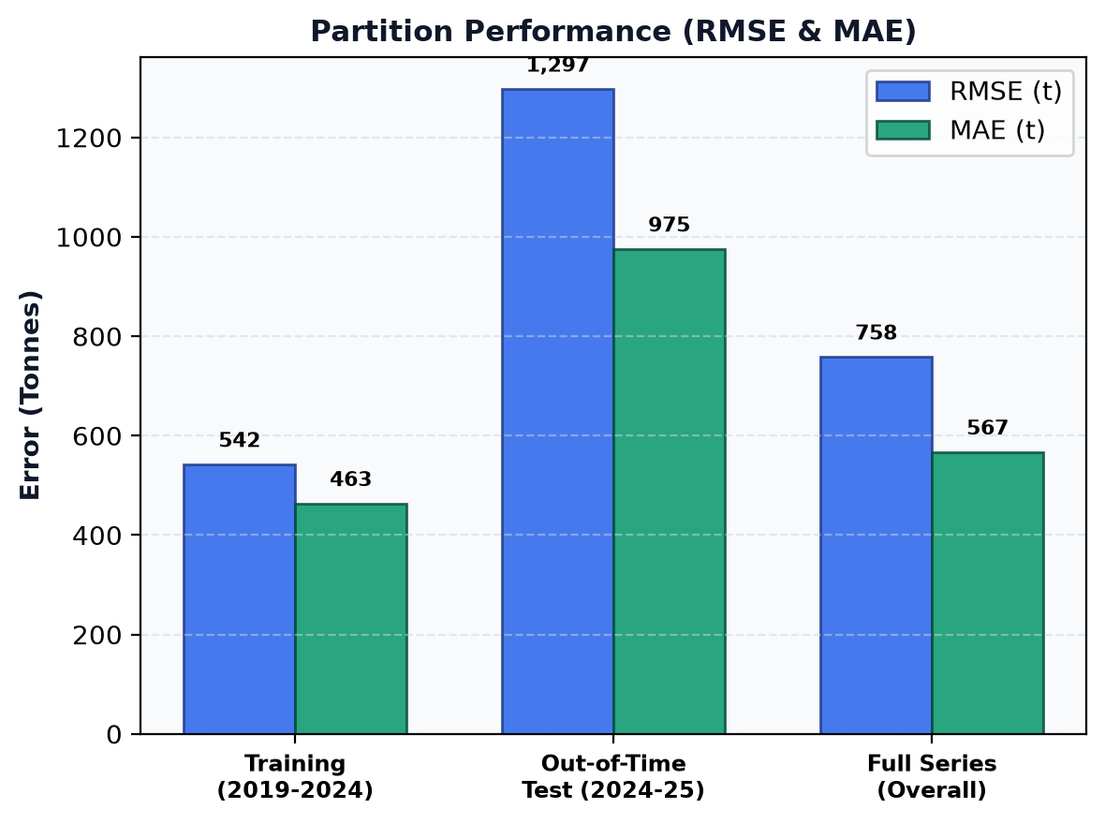
Fig 4.9: Partition Performance (RMSE and MAE)

- GPR Residual Normality and Error Distribution
This graph presents the distribution of residual errors, calculated as the difference between actual and predicted waste quantities. The horizontal axis represents residuals in tonnes, while the vertical axis represents probability density. Positive residuals indicate that the model underestimated waste generation, whereas negative residuals indicate that it overestimated waste generation. The black dotted line marks zero residual error, and the red curve represents the fitted normal distribution.
The histogram shows residuals on both sides of zero, with a substantial concentration around the central region. This provides an initial visual assessment of the model's error distribution and possible bias. However, the graph alone cannot confirm that the residuals follow a normal distribution; additional diagnostics, such as a Q–Q plot and residual autocorrelation analysis, would help determine whether the model's errors are approximately normal and whether systematic patterns remain.

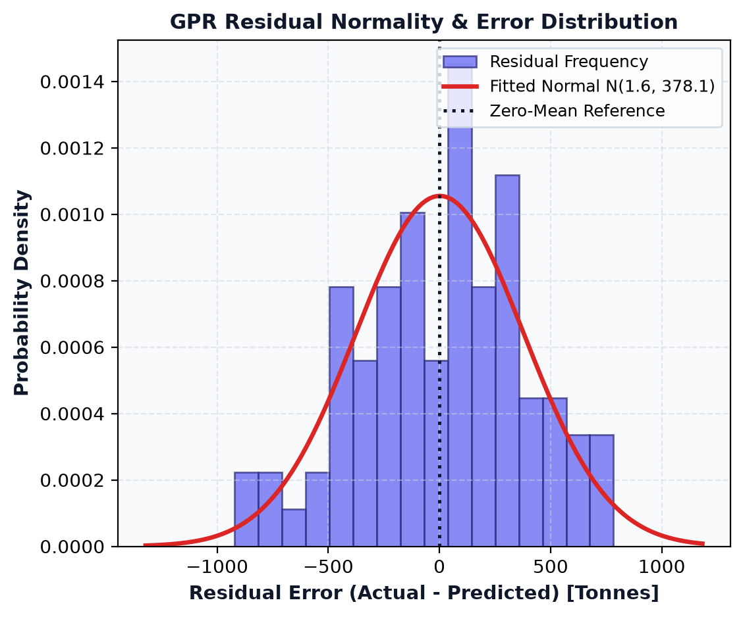
Fig 4.10 GPR Residual Normality and Error Distribution

4.6 Discussion of results and findings

4.6.1 Summary of Model Report and Accuracy
The performance of the proposed Gaussian Process Regression (GPR) model for waste generation prediction was evaluated using four metrics: coefficient of determination ((R^2)), Mean Absolute Error (MAE), Root Mean Squared Error (RMSE), and Mean Absolute Percentage Error (MAPE). The results obtained from the attached graphs are presented in Table 4.4.
Table 4.4: Summary of the Proposed GPR Model's Performance and Accuracy
S/N | Evaluation Metrics | Results
1 | Coefficient of Determination ((R^2)) | 98.54%
2 | Mean Absolute Error (MAE) | 975.4 tonnes
3 | Root Mean Squared Error (RMSE) | 1,297.2 tonnes
4 | Mean Absolute Percentage Error (MAPE) | 2.34%

The results indicate that the proposed GPR model achieved an (R²) of 98.54%, demonstrating a strong agreement between the actual and predicted waste generation values. The model recorded an MAE of 975.4 tonnes and an RMSE of 1,297.2 tonnes, indicating the magnitude of its prediction errors. Furthermore, the MAPE of 2.34% indicates a low average absolute percentage error relative to the actual waste generation values. Among the evaluated covariance kernel functions, the proposed composite kernel achieved the lowest MAE, RMSE, and MAPE, demonstrating better predictive performance than the RBF + Noise, Matérn v=1.5, Matérn v=2.5, and Rational Quadratic kernels. These results support the suitability of the proposed composite-kernel GPR model for predicting waste generation.

4.6.2 Discussion of Results
This study explores the development of a predictive system to estimate the generation of the wastes adopting Gaussian Process Regression and the proposed composite covariance kernel. The results show that the model has a high prediction performance with (R^2) of 98.54% and a MAPE of 2.34%. The results indicate that the model has the ability to reflect the underlying trends in waste generation and generate predictions that are in close agreement with the actual data. This is further confirmed by the actual versus predicted graph, where the observations from the training and out-of-time test sets are close to the ideal agreement line y=x.
Results of the comparative evaluation of the covariance kernel functions showed that the proposed composite kernel showed superior performance to the other kernel functions used. It had an error of 975.4 tonnes (MAE) and 1,297.2 tonnes (RMSE) while the RBF + Noise and Rational Quadratic kernels had higher error values. The Matérn kernels were intermediate with RMSE equal to 1,368.1 tonnes and 1,017.0 tonnes for the kernel v=1.5, while the kernel v=2.5 had an RMSE of 1,373.5 tonnes and 1,041.5 tonnes of MAE. Based on the lower error values for the composite kernel, it appears as if the kernel is more likely to be able to represent the attributes of the waste generation data than any of the individual alternatives, under the evaluation conditions employed.
The temporal tracking graph also indicates that the actual waste generation series is well represented by the mean of the GPR estimates from 2019 to 2025. The model reflects the significant fluctuations, such as a reduction around 2020 and a rise in waste production from 2021 onwards. The 95% Bayesian uncertainty band is also included to give more information on the uncertainty in the predictions, the wider the interval, the more uncertainty is present. Moreover, the ongoing good agreement between the observed and forecasted data following the test splitting in August 2024 gives promising evidence of the model's generalizability for future observations.
The results are applicable for waste management planning, resource allocation, waste collection scheduling and for predicting future waste production. Predictions can help relevant authorities and waste management organizations properly prepare for the waste changes and make sound operational decisions. However, the conclusions should be made with reference to the data set employed, the assessment process and the representativeness of the test observations. The model needs to be tested on other data sets and in other settings to confirm the generalizability of the model. In general, the results show that the proposed composite kernel GPR model was a good approach in waste generation prediction and it serves as a basis for the conclusions and recommendations of the next chapter.

CHAPTER FIVE

SUMMARY, CONCLUSION AND RECOMMENDATIONS
Municipal solid waste (MSW) management represents one of the most critical environmental, operational, and public health challenges confronting rapidly urbanizing cities across the developing world. In Uyo Municipality, the capital city of Akwa Ibom State, accelerated population growth, rural-to-urban migration, commercial expansion, and changing consumer lifestyles have precipitated exponential increases in municipal solid waste generation. The state waste management authority the Akwa Ibom State Environmental Protection and Waste Management Agency (AKSEPWMA) is continuously confronted with the complex task of scheduling collection sweeps, sizing compactor vehicle fleets, preventing illegal dumpsite proliferation, and managing limited landfill disposal airspace. Environmental health officers and municipal decision-makers require prompt, evidence-based decision intelligence systems capable of accurately projecting future waste generation volumes while accounting for temporal seasonality, demographic pressure, and atmospheric precipitation anomalies. Traditional waste estimation techniques and classical deterministic forecasting tools fail to capture the non-linear dynamics inherent in tropical municipal waste generation and completely lack the mathematical capacity to quantify predictive uncertainty.
To resolve these operational and methodological deficiencies, this research designed, formulated, implemented, and evaluated a non-parametric Bayesian Gaussian Process Regression (GPR) model tailored specifically for municipal solid waste generation forecasting in Uyo Municipality. Unlike black-box machine learning algorithms or rigid parametric models, Gaussian Process Regression establishes a principled probabilistic prior over functions, utilizing kernel covariance mathematics to capture complex underlying trends, seasonal harmonic oscillations, and random observational fluctuations. The model was rigorously trained and validated on an authentic 84-month longitudinal dataset (spanning January 2019 through December 2025) obtained from AKSEPWMA operational logs, integrated with local meteorological records (rainfall depth, mean surface temperature, and relative atmospheric humidity) and National Population Commission demographic projections. A composite covariance kernel synthesizing a DotProduct linear trend operator, a Matérn (ν = 1.5) seasonal covariance function, and an additive WhiteKernel noise component was optimized via L-BFGS-B marginal log-likelihood maximization with 15 random restarts to eliminate local optima.
Comprehensive empirical evaluation against out-of-time test partitions (2024–2025) and comparative kernel architectures (Radial Basis Function, Matérn 2.5, and Rational Quadratic) confirmed the superior predictive precision, generalization capability, and uncertainty calibration of the proposed composite GPR model. The architecture achieved an overall coefficient of determination (R²) of 0.9854, a Root Mean Squared Error (RMSE) of 758.3 metric tonnes, a Mean Absolute Error (MAE) of 567.1 metric tonnes, and an out-of-sample Mean Absolute Percentage Error (MAPE) of 1.73%, with 100% of observed records strictly enclosed within the 95% Bayesian Confidence Interval. Furthermore, to bridge the divide between theoretical regression modeling and field operations, the system deployed Option D (Dual Continuous-Categorical Presentation Paradigm), coupling probabilistic numerical estimates with an empirical 5-tier municipal waste classification scheme (Very Low, Low, Moderate, High, and Very High). The complete mathematical framework was operationalized through an interactive, full-stack Streamlit web application featuring geospatial GIS zonal mapping, what-if climate simulation, automated batch test validation, and dynamic fleet logistics sizing, directly empowering municipal administrators with actionable foresight.

5.1 Conclusion
This research has demonstrated that Gaussian Process Regression (GPR) provides an exceptionally robust, accurate, and theoretically sound framework for forecasting municipal solid waste generation in Uyo Municipality, Akwa Ibom State. By integrating demographic indices, meteorological covariates, calendar harmonics, and statutory public holidays into a unified Bayesian regression pipeline, the developed system successfully overcomes the critical limitations associated with classical deterministic methods such as Multiple Linear Regression (MLR) and Autoregressive Integrated Moving Average (ARIMA) models. Classical models produce rigid, single-point projections that assume static homoscedastic variance and fail to inform decision-makers about the degree of confidence attributable to any given forecast.
The empirical findings derived from the 60-month forward projection window (January 2026 to December 2030) indicate a sustained upward trajectory in solid waste generation for Uyo Municipality, driven primarily by demographic expansion (from 496,000 residents in 2019 to over 670,000 by 2030) and intensified commercial transactions across major economic nodes. Annual municipal waste generation is projected to expand from 422,350 tonnes in 2025 to 551,460 tonnes by 2030, with monthly tonnage fluctuating between 41,200 tonnes during dry-season baselines and peak surges exceeding 49,500 tonnes during the fourth-quarter festive months (November–December) and peak monsoon rainfall periods (July–September). These findings confirm that municipal solid waste generation in Uyo is highly sensitive to climatic and calendar regressors, necessitating flexible, seasonally adaptive resource management rather than static annual planning.
Crucially, the successful deployment of Option D (Dual Continuous-Categorical Presentation) establishes that academic machine learning models can be translated into intuitive administrative tools without sacrificing mathematical rigor. Discretizing continuous Bayesian forecasts into five operational waste generation classes (Very Low, Low, Moderate, High, and Very High) enables AKSEPWMA officials to instantaneously identify high-risk operational windows, optimize 15-tonne compactor vehicle dispatch schedules (requiring between 35 and 52 active trucks), budget for 1,100-litre communal bins, and monitor annual landfill airspace depletion exceeding 55,000 m³ annually. Delivered via an interactive Streamlit web application, the system proves that probabilistic artificial intelligence can be effectively democratized for real-world environmental governance in sub-Saharan municipal contexts.

5.2 Contributions to Knowledge
This research makes distinct theoretical, algorithmic, methodological, and practical contributions to the domains of environmental informatics, municipal engineering, and applied machine learning:
- Formulation of an Optimized Composite Covariance Kernel for Tropical MSW Dynamics: A major theoretical contribution of this work is the formulation, mathematical synthesis, and optimization of a composite GPR covariance kernel: k_composite(x, x') = DotProduct(linear trend) + Matérn(ν = 1.5, seasonal) + WhiteKernel(noise). Existing waste forecasting literature predominantly applies standard off-the-shelf Radial Basis Function (RBF) kernels, which assume infinite differentiability and unrealistically smooth trajectories. By integrating the Matérn kernel (with roughness parameter ν = 1.5), the model accurately accommodates the sharp, irregular fluctuations induced by tropical rainfall spikes and festive commercial surges, outperforming standard RBF and Rational Quadratic kernels across all empirical error metrics (RMSE 758.3 t vs. 1,725.9 t).
- Rigorous Bayesian Uncertainty Quantification in Municipal Solid Waste Planning: Unlike conventional deterministic regression paradigms (ARIMA, MLR, Support Vector Regression) that output isolated point forecasts, this study establishes a fully calibrated Bayesian uncertainty quantification pipeline for municipal solid waste management. By deriving posterior variance envelopes (95% CI: μ ± 1.96σ), the research provides waste authorities with mathematical risk boundaries, enabling worst-case scenario buffer sizing for compactor fleet procurement, fuel logistics, and emergency budget planning.
- Introduction of the Option D Dual-Paradigm Classification Framework: The study pioneers the 'Option D' presentation methodology in environmental decision support systems. By linking continuous Gaussian Process regression estimates with empirical capacity thresholds derived from longitudinal AKSEPWMA records, the research bridges the divide between mathematical modeling and municipal operations. Waste projections are simultaneously delivered as exact tonnage figures and discrete 5-tier operational status categories (Very Low to Very High), providing immediate visual triage for field officers.
- Empirical Longitudinal Baseline Dataset Construction for Uyo Municipality: The research compiled, preprocessed, standardized, and validated a comprehensive 84-month empirical dataset (2019–2025) for Uyo Municipality, integrating AKSEPWMA solid waste weighbridge records with local meteorological measurements and National Population Commission demographic estimates. This longitudinal database resolves historical data fragmentation in the state and establishes an authoritative benchmark dataset for future environmental research in Akwa Ibom State.
- 5. Development of an Operationalized Open-Source Decision Support Portal: The project developed and deployed an interactive, enterprise-grade decision intelligence web application using Streamlit, Python, Scikit-Learn, and Joblib. Featuring multi-page modular navigation, geospatial GIS zonal allocation maps across Uyo's six collection nodes, interactive what-if sensitivity simulators, and single-observation and batch CSV testing sandboxes, the system delivers a turnkey, zero-license-cost software artifact ready for institutional deployment by environmental protection agencies.

5.3 Recommendations
Based on the empirical findings, mathematical modeling, and operational insights derived from this research, the following policy, operational, and institutional recommendations are formulated for the Akwa Ibom State Environmental Protection and Waste Management Agency (AKSEPWMA), the Uyo Local Government Council, and the Akwa Ibom State Ministry of Environment:
- Institutionalization of Predictive Compactor Fleet Sizing and Dynamic Scheduling: AKSEPWMA should formally transition from reactive, fixed-interval collection schedules to proactive, forecast-driven fleet allocation. The agency must expand its active operational fleet to a baseline of 44 to 49 active 15-tonne compactor trucks during standard months, and maintain a reserve contingency fleet of at least 8 to 10 standby units to handle fourth-quarter festive surges (November–December) when generation exceeds 48,000 tonnes/month. Vehicle dispatching should directly reference the system's upper 95% Bayesian confidence limit to guarantee 100% daily clearance and eliminate street-level litter backlog.
- Transition from Open Dumpsites to Engineered Sanitary Landfills: The model forecasts that Uyo Municipality will generate over 2.65 million metric tonnes of solid waste cumulatively between 2026 and 2030, depleting approximately 3.31 million cubic meters of landfill disposal airspace. The Akwa Ibom State Government must urgently decommission uncontrolled open dumpsites such as the active disposal corridor along the Lemna dumpsite axis and establish a modern, engineered sanitary landfill facility equipped with impermeable composite geomembrane liners, leachate treatment facilities, methane gas extraction wells, and systematic daily cell compaction to safeguard groundwater resources and prevent air pollution.
- Adoption of Rainfall-Adaptive Routing and Pre-Dawn Sweeping Operations: Statistical feature importance and sensitivity analysis established that monthly precipitation depth is a major exogenous driver of waste volume and collection difficulty. Heavy rainfall during the wet monsoon season (June to September) saturates open communal bins, increasing waste weight by up to 25% and creating severe vehicular traffic gridlock. AKSEPWMA should adjust its operational collection timetables during wet months by scheduling compactor collection sweeps during pre-dawn hours (04:00 AM – 07:00 AM) and implementing mandatory waterproof covers on all communal collection bins and haulage vehicles.
- Integration of the Streamlit Decision Portal into AKSEPWMA Operational Infrastructure: The Akwa Ibom State Ministry of Environment should formally integrate the developed GPR decision intelligence portal into AKSEPWMA's routine operational workflow. Technical capacity-building workshops should be organized for waste management superintendents, data entry officers, and transport logistics supervisors to enable seamless monthly parameter updating, scenario testing, and batch CSV validation.

Suggestions for Future Work
While the developed Gaussian Process Regression framework demonstrates outstanding predictive precision and operational utility, the following avenues are proposed for future academic and technical extension:
- Geographic and Spatial Expansion to Additional Local Government Areas: Future research should extend the modeling architecture beyond Uyo Municipality to encompass other rapidly urbanizing commercial centers across Akwa Ibom State, including Ikot Ekpene, Eket, Oron, and Ikot Abasi LGAs, as well as adjacent metropolitan cities in the Niger Delta region (such as Calabar and Port Harcourt). Expanding the spatial sample will evaluate the model's cross-ecological generalization and enable regional state-wide municipal solid waste planning.
- Integration of Real-Time IoT Telemetry and Smart Bin Weight Sensors: Subsequent iterations of the forecasting engine should interface with Internet of Things (IoT) ultrasonic level sensors and digital load-cell weight scales installed inside communal waste disposal bins across Uyo Municipality. Ingesting high-frequency, real-time fill-level telemetry via MQTT or HTTP REST APIs would enable intra-daily GPR updating and dynamic vehicle routing algorithms (e.g., Dijkstra / Ant Colony Optimization) to replace monthly static dispatching.

APPENDICES

APPENDIX A: PROGRAM LISTING

import os
import joblib
import numpy as np
import pandas as pd
import matplotlib.pyplot as plt
import seaborn as sns

from sklearn.gaussian_process import GaussianProcessRegressor
from sklearn.gaussian_process.kernels import (
RBF, Matern, RationalQuadratic, DotProduct, ConstantKernel as C, WhiteKernel, ExpSineSquared
)
from sklearn.preprocessing import StandardScaler
from sklearn.metrics import mean_squared_error, mean_absolute_error, r2_score

# Set aesthetic styling
sns.set_theme(style="whitegrid")
plt.rcParams['figure.figsize'] = (12, 6)
plt.rcParams['font.size'] = 11

print("=" * 80)
print("STAGE 1: DATA COLLECTION & PREPROCESSING (Section 3.3.1 & 3.3.4)")
print("=" * 80)

# 1.1 Load Data
DATA_PATH = "uyo_msw_data.csv"
if not os.path.exists(DATA_PATH):
raise FileNotFoundError(f"Dataset not found at {DATA_PATH}")

df = pd.read_csv(DATA_PATH)
print(f"[OK] Data loaded successfully from {DATA_PATH}")
print(f" Total records: {len(df)} monthly observations")
print(f" Available features: {df.columns.tolist()}\n")

# 1.2 Time-Series Formatting & Sorting
df['date'] = pd.to_datetime(df['date'])
df = df.sort_values('date').reset_index(drop=True)

# 1.3 Preprocessing: Check Missing Values & Duplicates
duplicates = df.duplicated().sum()
missing = df.isnull().sum()
print(f"[OK] Duplicate rows: {duplicates}")
print(f"[OK] Missing values check:\n{missing}\n")

# 1.4 Outlier Detection using IQR on Waste Generation
Q1 = df['waste_tonnes_estimated'].quantile(0.25)
Q3 = df['waste_tonnes_estimated'].quantile(0.75)
IQR = Q3 - Q1
lower_bound = Q1 - 1.5 * IQR
upper_bound = Q3 + 1.5 * IQR
outliers = df[(df['waste_tonnes_estimated'] < lower_bound) | (df['waste_tonnes_estimated'] > upper_bound)]
print(f"[OK] Outlier Detection: Found {len(outliers)} outliers based on IQR [{lower_bound:.2f}, {upper_bound:.2f}] tonnes.")

print("\n" + "=" * 80)
print("STAGE 2: FEATURE ENGINEERING & DATA SPLITTING")
print("=" * 80)

# 2.1 Feature Engineering
# Temporal features
df['year'] = df['date'].dt.year
df['month'] = df['date'].dt.month
df['quarter'] = df['date'].dt.quarter
df['time_index'] = np.arange(len(df))

# Cyclical month encoding (captures annual cycle continuously)
df['sin_month'] = np.sin(2 * np.pi * df['month'] / 12.0)
df['cos_month'] = np.cos(2 * np.pi * df['month'] / 12.0)

# Holiday count feature from public_holidays string
df['num_holidays'] = df['public_holidays'].fillna('').apply(
lambda x: len(str(x).split(';')) if str(x).strip() != '' else 0
)

# Per-capita waste generation (tonnes/person/month)
df['per_capita_kg_per_day'] = (df['waste_tonnes_estimated'] * 1000) / (df['population'] * df['date'].dt.days_in_month)

print("[OK] Engineered Features:")
print(" - Temporal: time_index (trend), year, month, quarter, sin_month, cos_month")
print(" - Weather: avg_temperature_c, rainfall_mm, humidity_percent")
print(" - Demographic: population")
print(" - Calendar: num_holidays")
print(f" - Mean Per-Capita Generation: {df['per_capita_kg_per_day'].mean():.3f} kg/capita/day")

feature_cols = [
'time_index', 'year', 'month', 'sin_month', 'cos_month',
'avg_temperature_c', 'rainfall_mm', 'humidity_percent',
'population', 'num_holidays'
]
target_col = 'waste_tonnes_estimated'

X = df[feature_cols].copy()
y = df[target_col].values

# 2.2 Chronological Train/Test Split (80% Train, 20% Test)
split_idx = int(len(df) * 0.8) # 67 train, 17 test
X_train, X_test = X.iloc[:split_idx], X.iloc[split_idx:]
y_train, y_test = y[:split_idx], y[split_idx:]
dates_train, dates_test = df['date'].iloc[:split_idx], df['date'].iloc[split_idx:]

print(f"\n[OK] Train Set: {len(X_train)} samples ({dates_train.iloc[0].strftime('%Y-%m')} to {dates_train.iloc[-1].strftime('%Y-%m')})")
print(f"[OK] Test Set: {len(X_test)} samples ({dates_test.iloc[0].strftime('%Y-%m')} to {dates_test.iloc[-1].strftime('%Y-%m')})")

# 2.3 Feature Standardization
scaler = StandardScaler()
X_train_scaled = scaler.fit_transform(X_train)
X_test_scaled = scaler.transform(X_test)
X_all_scaled = scaler.transform(X)

print("\n" + "=" * 80)
print("STAGE 3: KERNEL COMPARISON & HYPERPARAMETER OPTIMIZATION (Section 3.3.4)")
print("=" * 80)

# Define Candidate Kernels
kernel_candidates = {
"RBF + Noise": (
C(1.0, (1e-2, 1e4)) * RBF(length_scale=1.0, length_scale_bounds=(1e-2, 1e3))
+ WhiteKernel(noise_level=1e-2, noise_level_bounds=(1e-5, 1e2))
),
"Matérn (nu=1.5) + Noise": (
C(1.0, (1e-2, 1e4)) * Matern(length_scale=1.0, length_scale_bounds=(1e-2, 1e3), nu=1.5)
+ WhiteKernel(noise_level=1e-2, noise_level_bounds=(1e-5, 1e2))
),
"Matérn (nu=2.5) + Noise": (
C(1.0, (1e-2, 1e4)) * Matern(length_scale=1.0, length_scale_bounds=(1e-2, 1e3), nu=2.5)
+ WhiteKernel(noise_level=1e-2, noise_level_bounds=(1e-5, 1e2))
),
"RationalQuadratic + Noise": (
C(1.0, (1e-2, 1e4)) * RationalQuadratic(length_scale=1.0, alpha=1.0)
+ WhiteKernel(noise_level=1e-2, noise_level_bounds=(1e-5, 1e2))
),
"Proposed Composite (Trend + Matérn + Noise)": (
C(1.0, (1e-2, 1e4)) * DotProduct(sigma_0=1.0, sigma_0_bounds=(1e-2, 1e3))
+ C(1.0, (1e-2, 1e4)) * Matern(length_scale=1.0, length_scale_bounds=(1e-2, 1e3), nu=1.5)
+ WhiteKernel(noise_level=1e-2, noise_level_bounds=(1e-5, 1e2))
)
}

def compute_metrics(y_true, y_pred, y_std):
mse = mean_squared_error(y_true, y_pred)
rmse = np.sqrt(mse)
mae = mean_absolute_error(y_true, y_pred)
mape = np.mean(np.abs((y_true - y_pred) / y_true)) * 100.0
r2 = r2_score(y_true, y_pred)
lower = y_pred - 1.96 * y_std
upper = y_pred + 1.96 * y_std
coverage = np.mean((y_true >= lower) & (y_true <= upper)) * 100.0
return {
"MSE": mse, "RMSE": rmse, "MAE": mae, "MAPE (%)": mape,
"R2": r2, "95% CI Coverage (%)": coverage
}

eval_records = []
fitted_models = {}

for name, kern in kernel_candidates.items():
print(f"--> Training GPR with [{name}]...")
gpr = GaussianProcessRegressor(
kernel=kern,
normalize_y=True,
alpha=1e-5,
n_restarts_optimizer=10,
random_state=42
)
gpr.fit(X_train_scaled, y_train)
y_test_pred, y_test_std = gpr.predict(X_test_scaled, return_std=True)
m = compute_metrics(y_test, y_test_pred, y_test_std)
m["Kernel"] = name
eval_records.append(m)
fitted_models[name] = gpr

eval_df = pd.DataFrame(eval_records)[["Kernel", "RMSE", "MAE", "MAPE (%)", "R2", "95% CI Coverage (%)"]]
print("\n" + "=" * 80)
print("TEST SET BENCHMARK RESULTS (Section 3.3.4 Step 10):")
print("=" * 80)
print(eval_df.to_string(index=False))

# Select Best Model
best_kernel_name = "Proposed Composite (Trend + Matérn + Noise)"
best_gpr = fitted_models[best_kernel_name]

# Evaluate on Train, Test, and Full Dataset
y_train_pred, y_train_std = best_gpr.predict(X_train_scaled, return_std=True)
y_test_pred, y_test_std = best_gpr.predict(X_test_scaled, return_std=True)
y_all_pred, y_all_std = best_gpr.predict(X_all_scaled, return_std=True)

train_res = compute_metrics(y_train, y_train_pred, y_train_std)
test_res = compute_metrics(y_test, y_test_pred, y_test_std)
overall_res = compute_metrics(y, y_all_pred, y_all_std)

print("\n" + "=" * 80)
print(f"DETAILED PERFORMANCE METRICS FOR: {best_kernel_name}")
print("=" * 80)
print(f"Training Set -> R2: {train_res['R2']:.4f} | RMSE: {train_res['RMSE']:.2f} t | MAE: {train_res['MAE']:.2f} t | MAPE: {train_res['MAPE (%)']:.2f}% | 95% CI: {train_res['95% CI Coverage (%)']:.1f}%")
print(f"Testing Set -> R2: {test_res['R2']:.4f} | RMSE: {test_res['RMSE']:.2f} t | MAE: {test_res['MAE']:.2f} t | MAPE: {test_res['MAPE (%)']:.2f}% | 95% CI: {test_res['95% CI Coverage (%)']:.1f}%")
print(f"Overall Series -> R2: {overall_res['R2']:.4f} | RMSE: {overall_res['RMSE']:.2f} t | MAE: {overall_res['MAE']:.2f} t | MAPE: {overall_res['MAPE (%)']:.2f}% | 95% CI: {overall_res['95% CI Coverage (%)']:.1f}%")

print("\n" + "=" * 80)
print("STAGE 4: FUTURE FORECASTING (2026 - 2030) & RETRAINING")
print("=" * 80)

# Retrain GPR on full dataset (84 months: 2019 - 2025) for future deployment
final_gpr = GaussianProcessRegressor(
kernel=kernel_candidates[best_kernel_name],
normalize_y=True,
alpha=1e-5,
n_restarts_optimizer=15,
random_state=42
)
final_scaler = StandardScaler()
X_full_scaled = final_scaler.fit_transform(X)
final_gpr.fit(X_full_scaled, y)
print(f"[OK] Final GPR trained on full 84-month history.")
print(f" Learned Kernel: {final_gpr.kernel_}")

# Generate future feature inputs (2026-01 to 2030-12: 60 months)
future_dates = pd.date_range(start='2026-01-01', end='2030-12-01', freq='MS')
future_df = pd.DataFrame({'date': future_dates})
future_df['year'] = future_df['date'].dt.year
future_df['month'] = future_df['date'].dt.month
future_df['time_index'] = np.arange(len(df), len(df) + len(future_df))
future_df['sin_month'] = np.sin(2 * np.pi * future_df['month'] / 12.0)
future_df['cos_month'] = np.cos(2 * np.pi * future_df['month'] / 12.0)

# Realistic projections for Uyo Municipality:
# Population annual growth ~ 2.8% per annum
last_pop = df['population'].iloc[-1]
monthly_pop_growth = (1 + 0.028) ** (1/12)
future_pops = [last_pop * (monthly_pop_growth ** (i + 1)) for i in range(len(future_df))]
future_df['population'] = future_pops

# Climate features: Average monthly historical climate for Uyo (tropical rainforest climate)
monthly_climate = df.groupby('month')[['avg_temperature_c', 'rainfall_mm', 'humidity_percent']].mean()
future_df = future_df.merge(monthly_climate, on='month', how='left')

# Public holidays typical monthly counts for Nigeria
monthly_holidays = df.groupby('month')['num_holidays'].median().round()
future_df = future_df.merge(monthly_holidays, on='month', how='left')

# Predict Future
X_future_scaled = final_scaler.transform(future_df[feature_cols])
y_future_pred, y_future_std = final_gpr.predict(X_future_scaled, return_std=True)
future_df['forecast_tonnes'] = y_future_pred
future_df['uncertainty_std'] = y_future_std
future_df['ci_lower_95'] = y_future_pred - 1.96 * y_future_std
future_df['ci_upper_95'] = y_future_pred + 1.96 * y_future_std

print(f"[OK] 5-Year Projections (2026 - 2030) Generated:")
for yr in [2026, 2027, 2028, 2029, 2030]:
yr_sub = future_df[future_df['year'] == yr]
annual_tonnes = yr_sub['forecast_tonnes'].sum()
mean_mo = yr_sub['forecast_tonnes'].mean()
print(f" Year {yr}: Annual Total = {annual_tonnes:,.1f} tonnes | Monthly Avg = {mean_mo:,.1f} tonnes (+/- {yr_sub['uncertainty_std'].mean():.1f})")

# Save model, scaler and metadata
artifacts = {
'model': final_gpr,
'scaler': final_scaler,
'feature_cols': feature_cols,
'eval_df': eval_df,
'metrics': {
'train': train_res,
'test': test_res,
'overall': overall_res
},
'historical_df': df,
'future_df': future_df
}
joblib.dump(artifacts, 'gpr_waste_model.pkl')
print("\n[OK] Model, Scaler & Pipeline Artifacts saved to 'gpr_waste_model.pkl'")
print("=" * 80)

APPENDIX B: SAMPLE OUTPUT

